**Class & Sequence**

296595 Long Yeh Min

1. You are working in company XYZ required you to develop a design package for library, and develop the following diagram:
2. Class Diagram

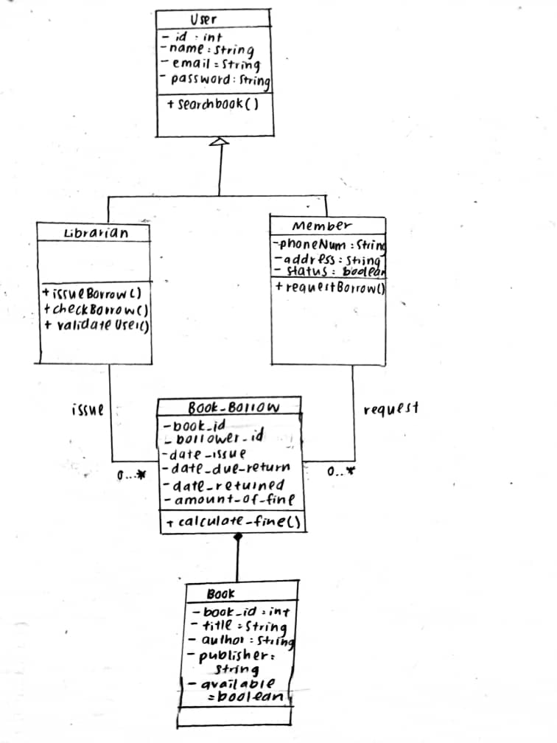

1. Sequence Diagram for borrow a book from library

